# Instructions for Simba Batch Job

### Overall

1. Open Windows Task Scheduler
2. Create a Task for each simulation to be run (see below)
3. Delay the task start time as appropriate so that the number of processors (minus 1 for the operating system) on the machine are not less than the number of simulation running in parallel.

For example, with 10 simulation to run on a 4-core machine, only 3 can run in parallel. If each simulation takes about 1 hour (say 1:15 for sure) then schedule the simulations as follows:

* 00:00 Sims 1, 2, 3 (each separate tasks in Task Scheduler)
* 01:15 Sims 4, 5, 6 (again separate tasks in task scheduler)
* 02:30 Sims 7, 8, 9
* 03:45 Sim 10

Make sure that each Simba file to be run is sending output to its own folder (e.g. folder “Run 1” etc).

### Creating a Task

1. Set the task to run one time, as follows:

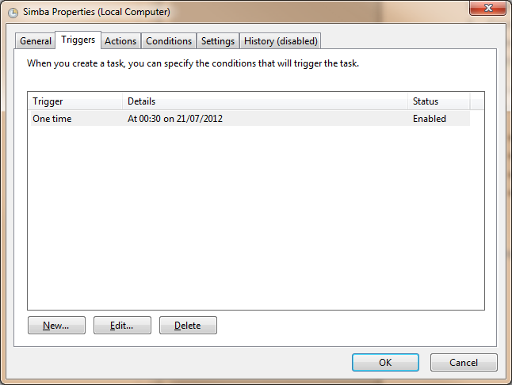

1. Set the Action to “Start a Program”. In the “Program/Script” box enter the path to the Simba executable file on your computer using quotations. For example:

"C:\Program Files (x86)\Colin Caprani Software\Simba.exe"

In the “Add arguments” box add in the path in quotations to the Simba file (*.sba) you wish to execute for this task, e.g.

"C:\Users\Colin Caprani\~Research\Workings\2011\Alessandro Bug checks\MLpaper - 12 05 21_test.sba"

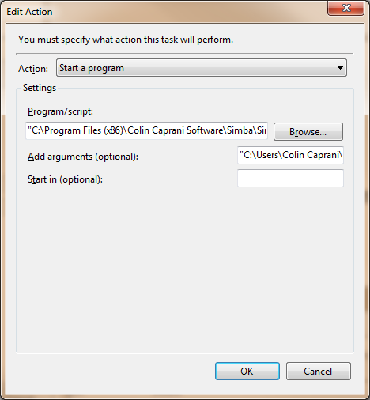

Press OK, and you should see something like this:

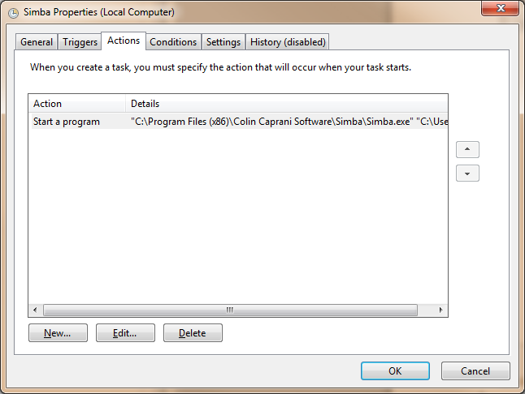

1. Press OK, and the Task is set.

### Troubleshooting

If the task does not execute, try two things:

1. Double and triple check that the paths to the Simba exe and the Simba file are exactly correct
2. Check the various settings in Task scheduler