INCEPTION REPORT

The EvolveTraffic Program:
A Traffic Microsimulation Model
for Bridge Loading

25 July 2008

Prof. Eugene O’Brien
Dr. Colin Caprani
Mr. Cillian Murphy
UCD Civil Engineering

Introduction
This report briefly outlines the progress made in implementing the EvolveTraffic program. It compares the progress made to-date against the specified capabilities that the completed program is to have. It is demonstrated that progress has been good, and that the completed software is on schedule for delivery on 22 August 2008.

Appendix A contains a detailed break down of the tasks to be met, as well as comments on the progress in relation to these tasks. Since well over half of the tasks have been completed, the project can be seen to be on schedule for completion on 22 August 2008.

This inception package includes:
- This Inception Report;
- EvolveTraffic Program with sample traffic files and input files;
- EvolveTraffic source code;
- EvolveTraffic source code documentation (go to index.html first).

The next section describes the use of the program as it currently stands.

EvolveTraffic – Description of Current Status
Currently, the program operates as follows:

- The configuration of the simulation is specified in the Simulation Configuration Dialog:

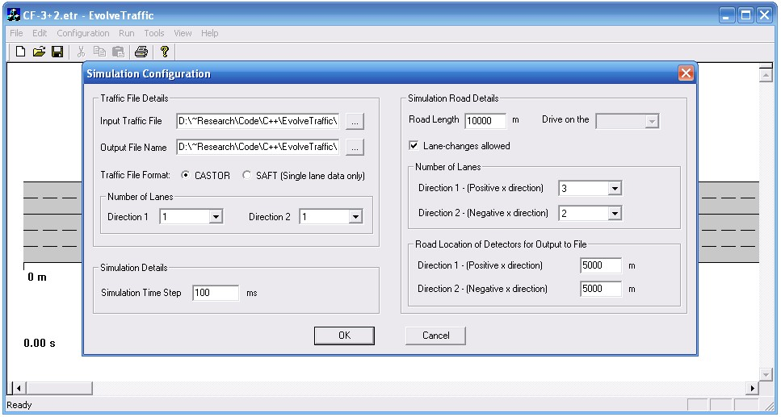

The input traffic file is specified, as is its format and the number of lanes of traffic the file contains. This last value is required because the program does not read in the file all at once, but line by line. This gives a significant performance advantage in computer memory and therefore the number of vehicles the program can handle.

The simulation time-step size is specified.

The Simulation Road details are specified, including future support for choosing the drive direction - currently it is drive on the right (European), as well as whether or not lane changing is allowed. Also, as may be noticed, the user can specify that the simulation road can have more lanes than the traffic file has, allowing the vehicles to behave as if on a different road. However, the simulation road cannot have fewer lanes than the input traffic file as all the vehicles must be placed upon the simulation road.

The location of the sensors for output of the vehicle arrivals is then specified for each direction in the “Road Location of Detectors for Output to File” section.

- The parameters of the Treiber IDM microsimulation model are defined in the Traffic Model Configuration Dialog:

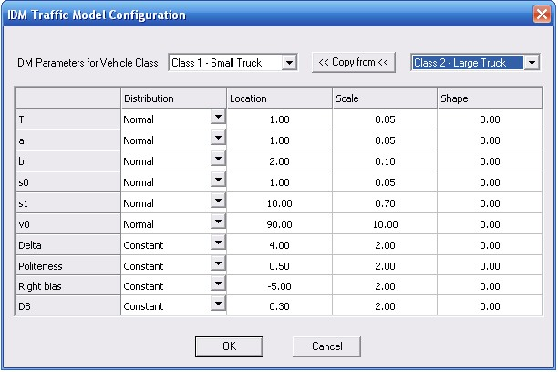

Five different classes of vehicles are allowed for:
- Class 0 – Cars
- Class 1 – Small Trucks
- Class 2 – Large Trucks
- Class 3 – Cranes
- Class 4 – Lowloaders
The vehicles have been broken into these classes as they are know to be the important classes for bridge loading.

The IDM parameters for each of these classes of vehicle can be specified as being either constant (deterministic) or variable, with the following distributions supported:
- Exponential;
- Log-normal;
- Gamma;
- Gumbel;
- Poisson;
- GEV;
- Normal.
The appropriate parameters for these distributions are then specified in the columns Location, Scale and Shape.

All of the information give to the program from Steps 1 and 2 can be saved to a *.etr file for easy restoration of a particular simulation configuration. Upon this information being available the simulation road is drawn to screen. Note that the parameters currently used demonstrate extreme bias to the right and left lanes.
- The simulation is started using Run > Evolve Traffic – note the use of the keyboard shortcuts to speed up input.

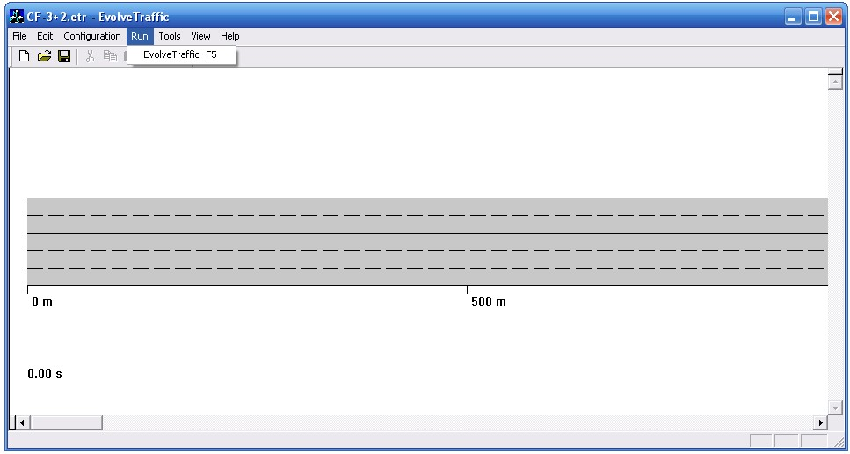

And immediately the simulation begins, with the starting time as that of the first vehicle in the input file, and the time increasing from there as specified by the simulation time-step:

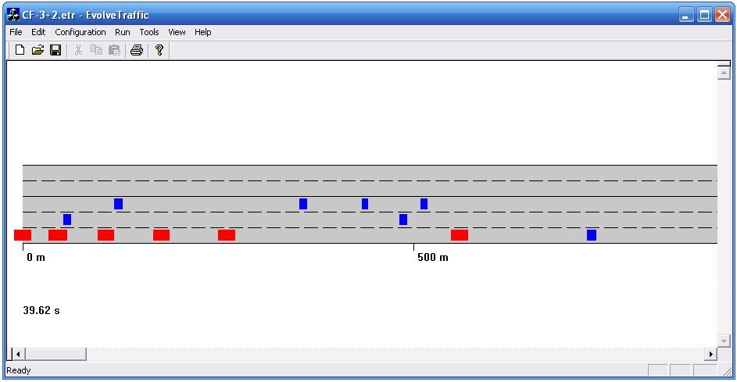

The different vehicle types are identified by different colours – here blue is Small Truck and Red is Large Truck.

During the simulation, using the tools menu, the user will be able to Zoom in and Zoom out to view the road as desired; Speed Up or Slow Down the simulation; Pause the simulation; or access the Preferences dialog:

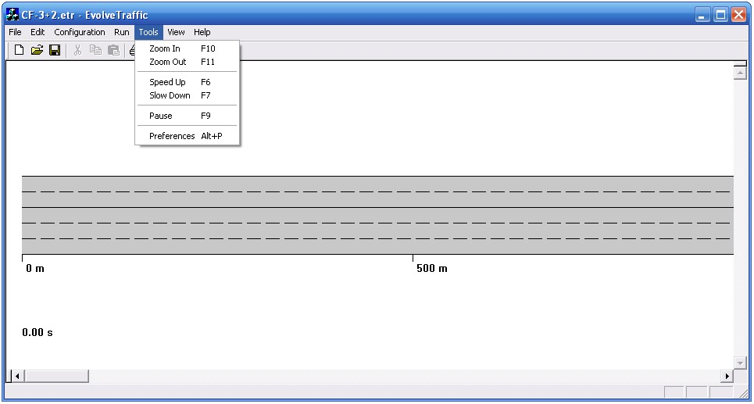

The Preferences dialog allows the user set variables that define the visualization of the traffic, including more refined definitions of the viewing scale and control over the speed of the simulation (Time Warp). Note that setting the Time Warp too high results in the program being unable to respond to further commands until the simulation has finished. This is normal behaviour.

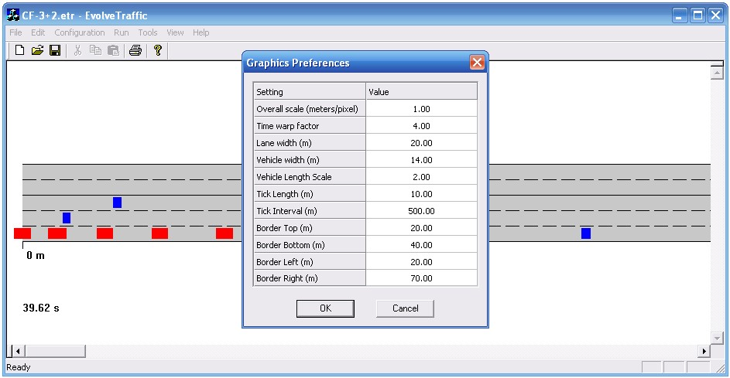

- Once the simulation is complete, or is stopped by the user, the Output traffic file, as specified by the user, is created in the specified directory.

Appendix – Summary of Tasks

Main Tasks As Per Contract | Identified Sub-Tasks | Completed? | Comments
Task 1 –  Implement Microsimulation Model | Support for CASTOR and SAFT file formats | Yes | SAFT implemented according to template provided. CASTOR format is long-established in UCD
 | Support for 2-lanes in the same direction | Yes | In fact up to 4 lanes are possible in each direction.
 | Support for different vehicle types | Yes | Up to 5 different vehicle types are allowed for in defining the microsimulation model parameters.
 | Support for at least 100 000 vehicles | Yes | The input file is read line by line, rather than all at once, and so theoretically an unlimited number of vehicles are possible.
 | Support for (a) no overtaking and (b) overtaking | Yes | User can choose to allow or prevent overtaking.
 | Support for speed limits | No | However, software architecture in place to implement this.
 | Support for gradient | No | As for speed limits.
 | Display output during simulation | Yes | Visualization is provided.
Task 2 –  Validate Model | Compare simple version to published results | Yes | This was completed during Dr Caprani’s visit to LCPC in March, 2008.
 | Compare macroscopic properties to known results | No | This item may be superseded by the calibration to actual site conditions – to be confirmed.
Task 3 –  Calibrate Model to RN 118 | Extract macroscopic properties from RN 118 data | No | In progress, following information on RN 118 data from LCPC.
 | Match program output to RN 118 macroscopic properties | No | Awaiting program output and RN118 statistics
Task 4 –  Provide basic documentation | Basic user manual | No | This will be done once the software has been completed, an initial draft is supplied with this document.
 | Source code documentation | Yes | This is being implemented during the writing of the program using Doxygen.
Task 5 –  Provide the source code | Provide Visual C++ 6 project source code | Semi | Interim source code provided.
Task 6 –  Provide Graphical User Interface | Visualization of driver behaviour | Yes | A visualization of the road and vehicles driving is provided.
 | Extraction of macroscopic properties | No | Virtual loop detectors are implemented; routines to extract statistics have not yet been included.

